6. Implement firewall for an organization

What is a Firewall?
A firewall is a network security device/software that controls incoming and outgoing network traffic based on predefined security rules.

Input
Kali Linux IP Address : 192.168.126.128
Windows IP Address : 192.168.126.1

Firewall tool : iptables
Protocol : TCP
HTTP Port : 80

Program:-
ifconfig
inet 192.168.126.128 netmask 255.255.255.0 broadcast 192.168.126.255
C:\Users\student>ipconfig
Ethernet adapter VMware Network Adapter VMnet8:
IPv4 Address. . . . . . . . . . . : 192.168.126.1
C:\Users\student>ping 192.168.126.128
sudo iptables -A INPUT -s 192.168.126.1 -j DROP
[sudo] password for kali: kali
C:\Users\student>ping 192.168.126.128 sudo iptables -D INPUT -s 192.168.126.1 -j DROP
C:\Users\student>ping 192.168.126.128 sudo service apache2 start sudo service mysql start
open windows browser enter kali IP address(192.168.126.128 )it’s open Apache 2 sudo iptables -A INPUT -s 192.168.126.1 -p tcp --destination-port 80 -j DROP
Here Apache2 get error(because we stopped port 80 using firewall) sudo iptables -D INPUT -s 192.168.126.1 -p tcp --destination-port 80 -j DROP
Output:-
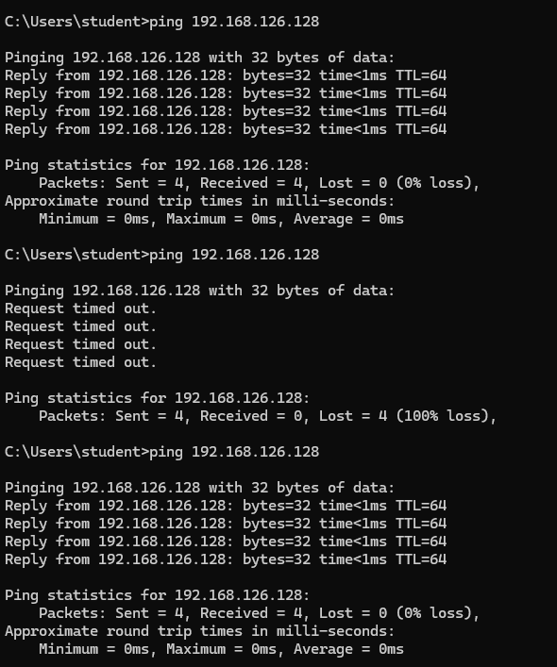

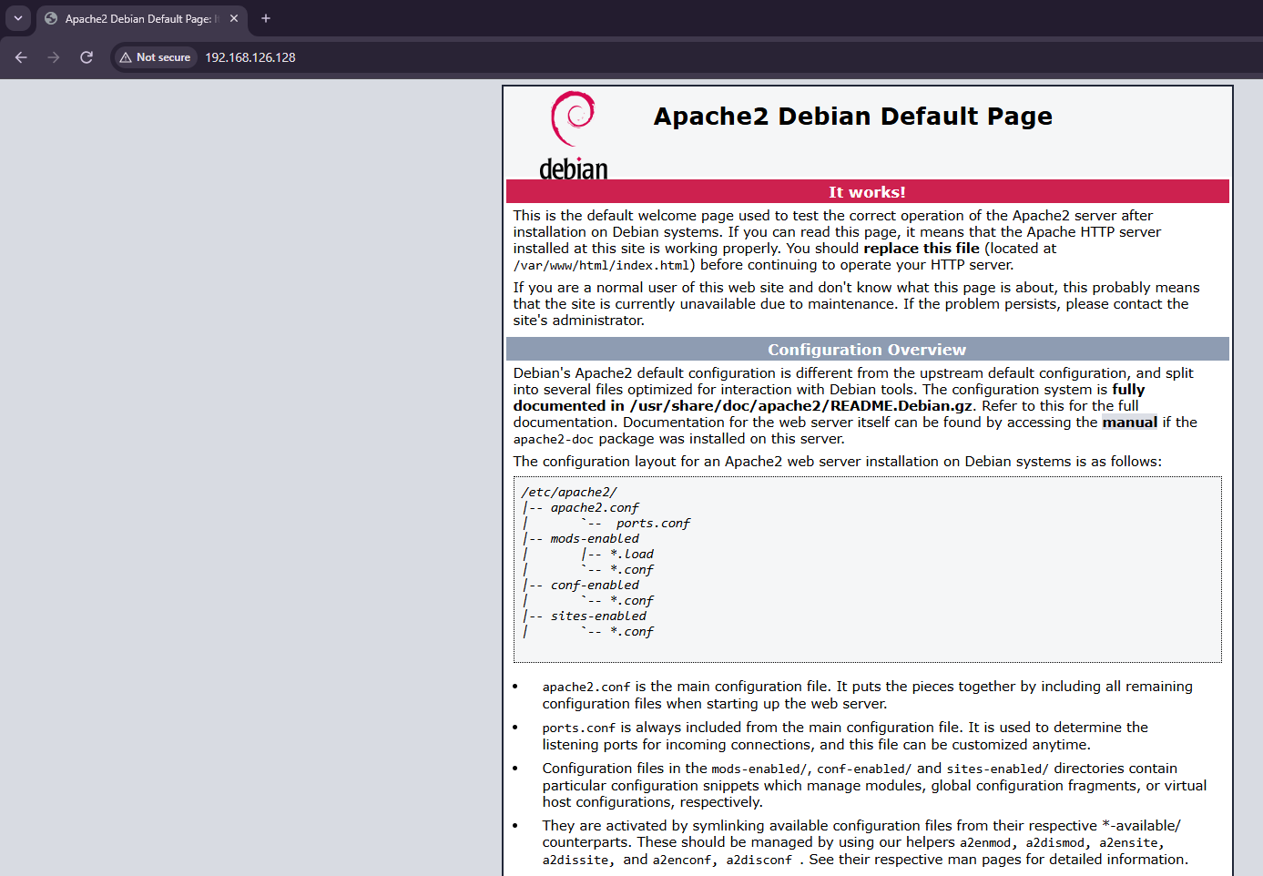

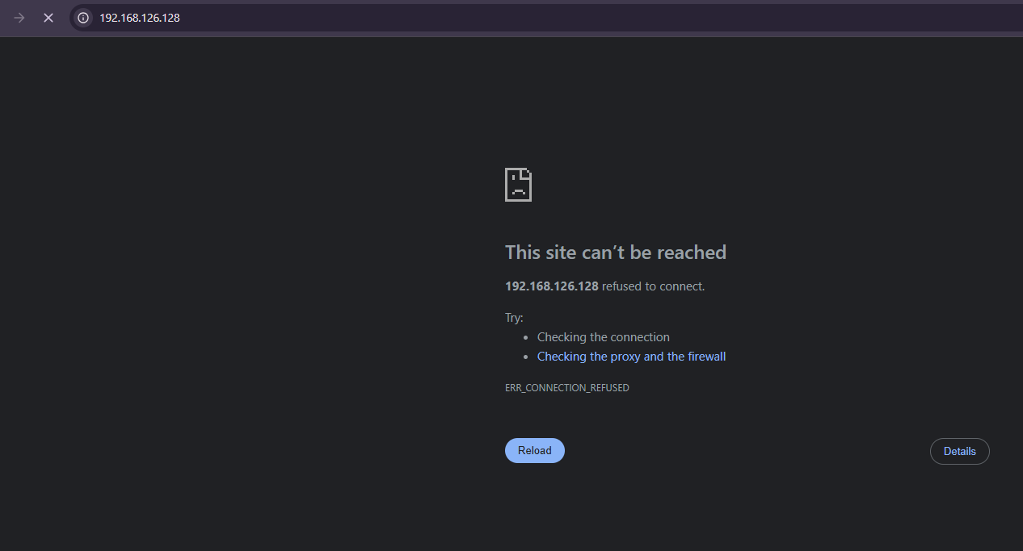
Result:-
Thus, the firewall was successfully configured and tested using iptables in Kali Linux. Incoming traffic from the specified IP address and HTTP traffic through TCP port 80 were successfully blocked. After removing the firewall rules, network communication and HTTP access were restored successfully.

Week 5:-
Result:- Thus, the website was successfully examined for common web vulnerabilities such as Cross-Site Scripting (XSS), Cross-Site Request Forgery (CSRF), and Command Injection. The vulnerabilities were identified and their impact was analyzed, demonstrating the importance of proper input validation, output encoding, authentication, authorization, and secure command handling.

